**PIZZA SALES POSTGRESQL QUERIES**

1. KPI’s

1. **Total Revenue:**

**SELECT SUM(total_price) as Total_price FROM pizzaSales;**

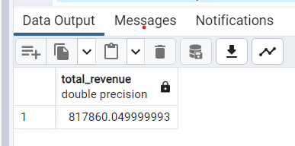

1. **Average Order Value:**

**SELECT (SUM(total_price)/COUNT(DISTINCT order_id)) as Avg_order FROM pizzaSales;**

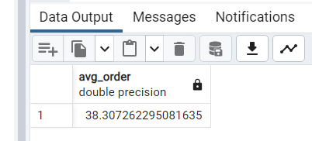

**SELECT CAST(ROUND**

**((SUM(total_price)/COUNT(DISTINCT order_id)) ::numeric,2)**

**as DOUBLE PRECISION) as avg_order from pizzaSales;** 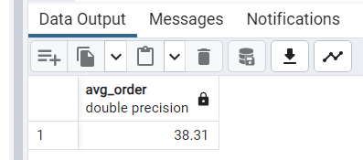

1. **Total Pizzas Sold**

**SELECT SUM(quantity) as total_pizza_sold FROM pizzaSales;**

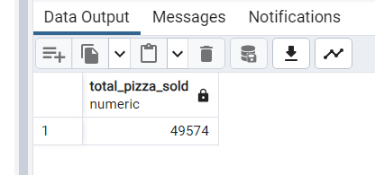

1. **Total Orders**

**SELECT COUNT(DISTINCT order_id) FROM pizzaSales;**



1. **Average Pizzas Per Order**

**SELECT (SUM(quantity)/COUNT(DISTINCT order_id)) AS Average_pizza_PerOrder FROM pizzaSales;**

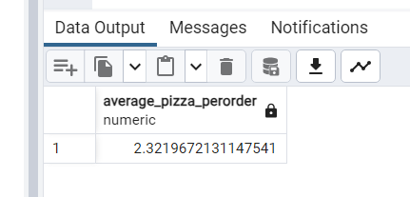 **or,**

**SELECT CAST(( SUM(quantity)/COUNT(DISTINCT order_id) ) AS NUMERIC(10,2)) FROM pizzaSales;**

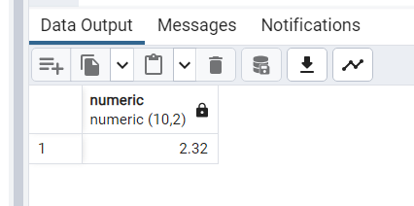

2. Daily Trend for Total Orders:

SELECT TO_CHAR(order_date, 'Day') AS Day_of_week,

COUNT(DISTINCT order_id) FROM pizzaSales

GROUP BY Day_of_week;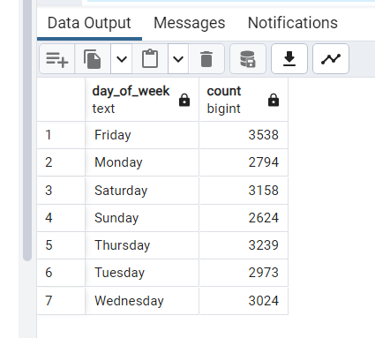

3. Monthly Trend for Orders

SELECT TO_CHAR(order_date,'Month') as month_of_year,

COUNT(DISTINCT order_id) FROM pizzaSales

GROUP BY month_of_year; 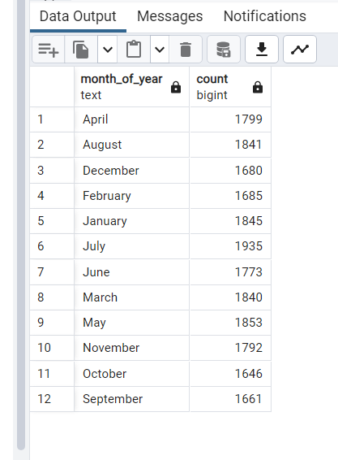

4. Percentage (%) Sales by Pizza Category:

SELECT pizza_category,

CAST(

ROUND(

(SUM(total_price)*100/(SELECT SUM(total_price) FROM pizzaSales))::numeric, 2)

as DOUBLE PRECISION) as percentage_sales_by_PizzaCategory

FROM pizzaSales GROUP BY pizza_category;

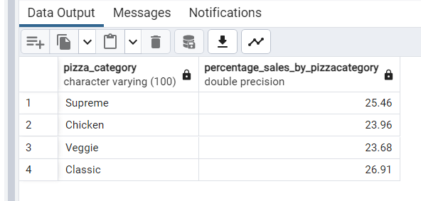

5. Percentage(%) Sales by Pizza size:

SELECT pizza_size, CAST(

ROUND((SUM(total_price)*100/(SELECT SUM(total_price) FROM pizzaSales))::numeric,2)

AS DOUBLE PRECISION) as percentage_sales_by_PizzaSize

FROM pizzaSales GROUP BY pizza_size;

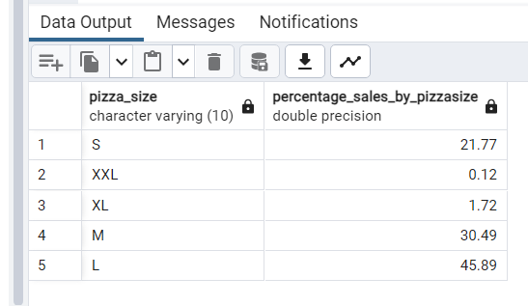

6. Total Pizzas sold by Pizza Category:

SELECT pizza_category, SUM(quantity) as total_quantity

FROM pizzaSales

GROUP BY pizza_category

ORDER BY total_quantity;

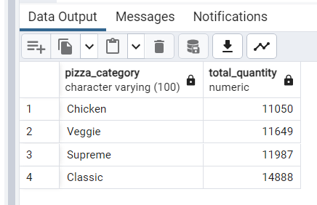

7. Top 5 Pizza name by revenue:

SELECT pizza_name,

CAST(ROUND(sum(total_price)::numeric,2) AS double precision) AS top_5_pizza_by_revenue

from pizzaSales

GROUP BY pizza_name

ORDER BY top_5_pizza_by_revenue DESC

LIMIT 5;

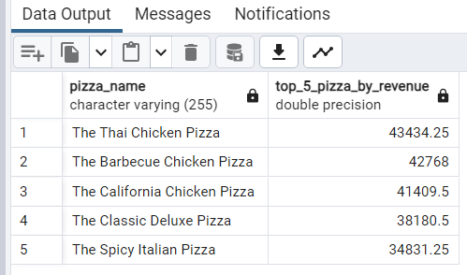

8. Bottom 5 pizza name by revenue:

SELECT pizza_name,

CAST(ROUND(SUM(total_price)::NUMERIC, 2) AS DOUBLE PRECISION) AS bottom_5_pizza_by_revenue

FROM pizzaSales

GROUP BY pizza_name

ORDER BY bottom_5_pizza_by_revenue ASC

LIMIT 5;

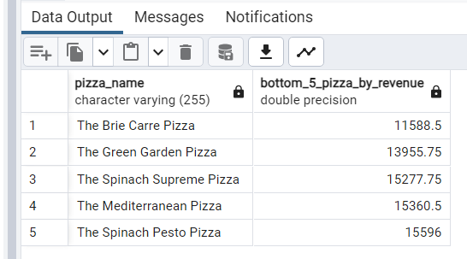

9. Top 5 Pizza by Quantity:

SELECT pizza_name, SUM(quantity) AS top_5_pizza_by_quantity

FROM pizzaSales GROUP BY pizza_name

ORDER BY top_5_pizza_by_quantity DESC LIMIT 5;

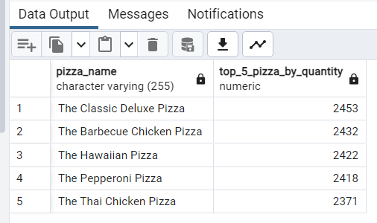

10. Bottom 5 Pizza by Quantity:

SELECT pizza_name, SUM(quantity) as bottom_5_pizza_by_quantity

FROM pizzaSales GROUP BY pizza_name

ORDER BY bottom_5_pizza_by_quantity LIMIT 5;

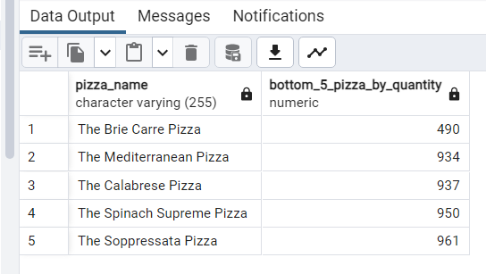

11. Top 5 Pizza name by total orders:

SELECT pizza_name, COUNT(DISTINCT order_id) as top_5_pizza_by_order

FROM pizzaSales

GROUP BY pizza_name

ORDER BY top_5_pizza_by_order DESC LIMIT 5 ;

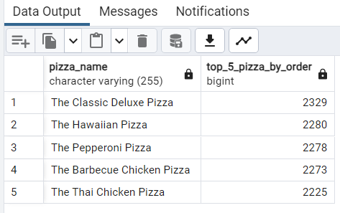

12. Bottom 5 Pizza Name by Total orders:

SELECT pizza_name, COUNT(DISTINCT order_id) AS bottom_5_pizza_by_order

FROM pizzaSales

GROUP BY pizza_name

ORDER BY bottom_5_pizza_by_order LIMIT 5;

